**SCREENSHOTS**

**GRADABLE PROJECT**

**Outputs:**

**Adding players:**

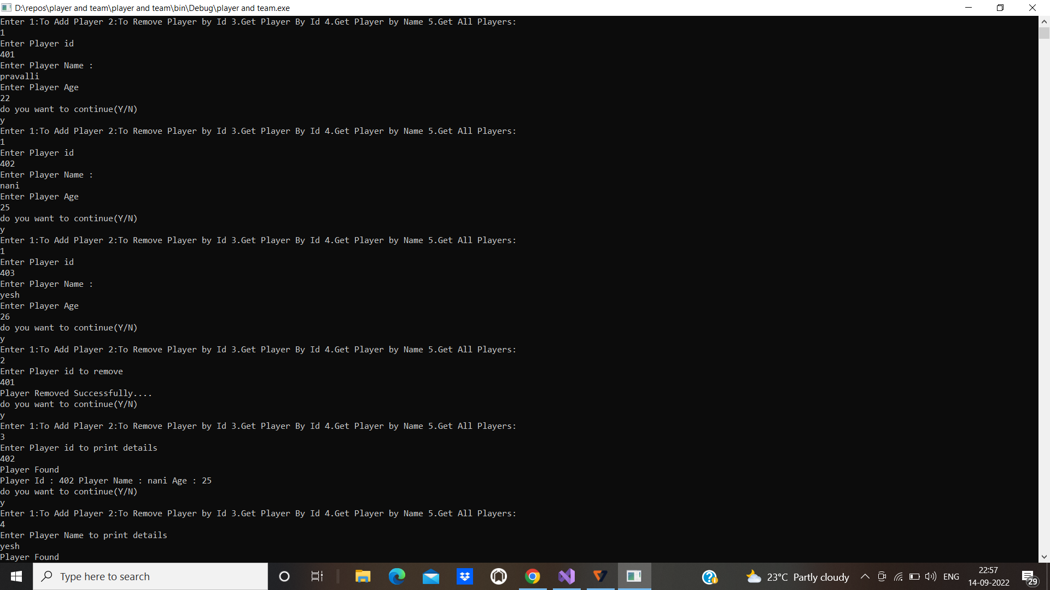

**Removing players:**



**Getting details by id:**



**Getting details by name:**

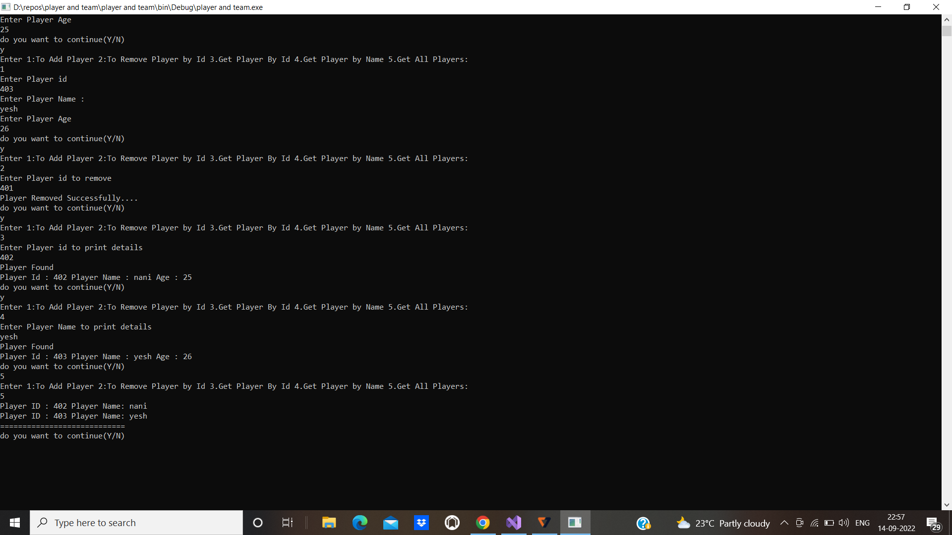

**Get all players:**



**Overall Output:**



